Lab 19 – Code Translation Report

NAME:J.ABHIRAM BATCH:06

ROLLNO:2403A51342

Lab Question 1 - Task 1

Prompt:
Translate Java Bubble Sort to Python.

Code: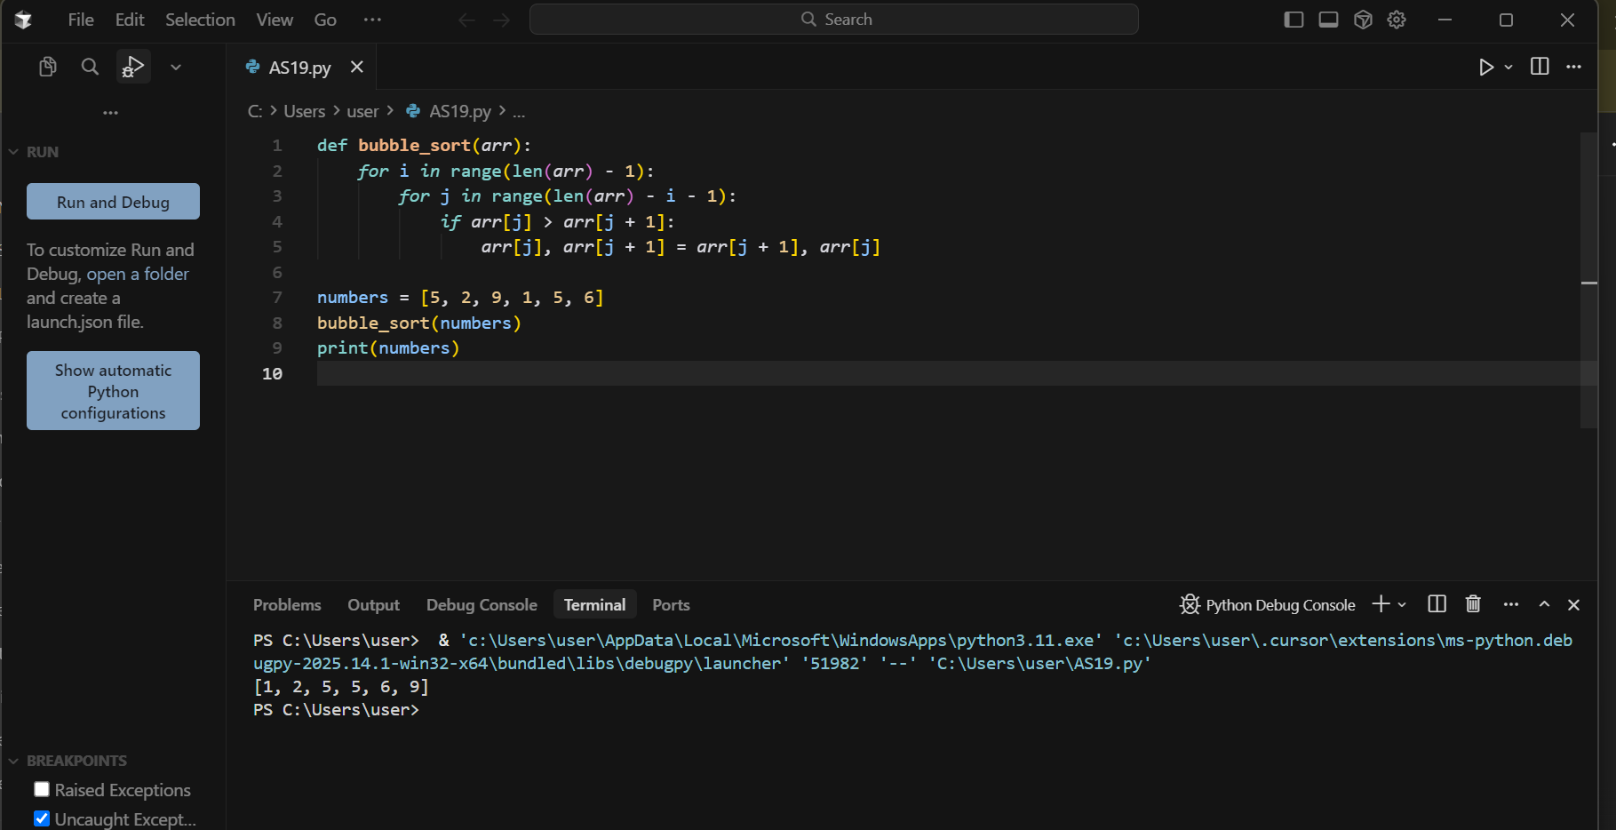

Output:
[1, 2, 5, 5, 6, 9]

Observation:
The Python code successfully replicates the Bubble Sort logic from Java.

Lab Question 1 - Task 2

Prompt:
Add error handling to detect empty or invalid lists.

Code: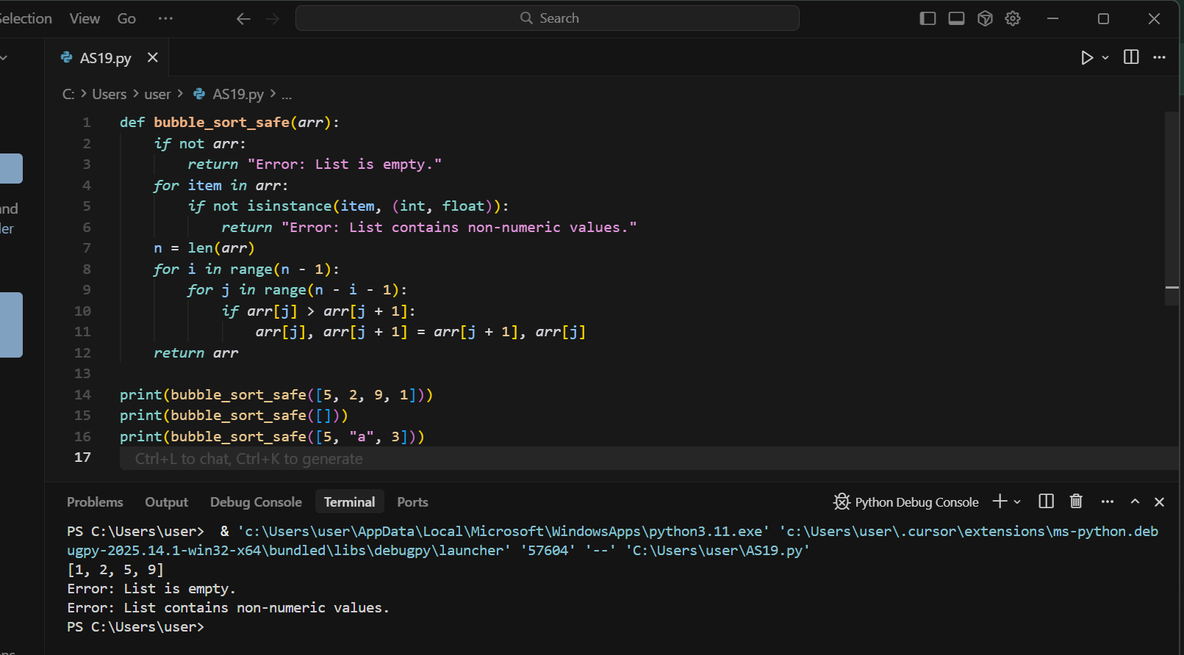

Output:
[1, 2, 5, 9]
Error: List is empty.
Error: List contains non-numeric values.

Observation:
Error handling ensures valid numeric input before sorting.

Lab Question 2 - Task 1

Prompt:
Translate C++ file read/write to JavaScript (Node.js).

Code: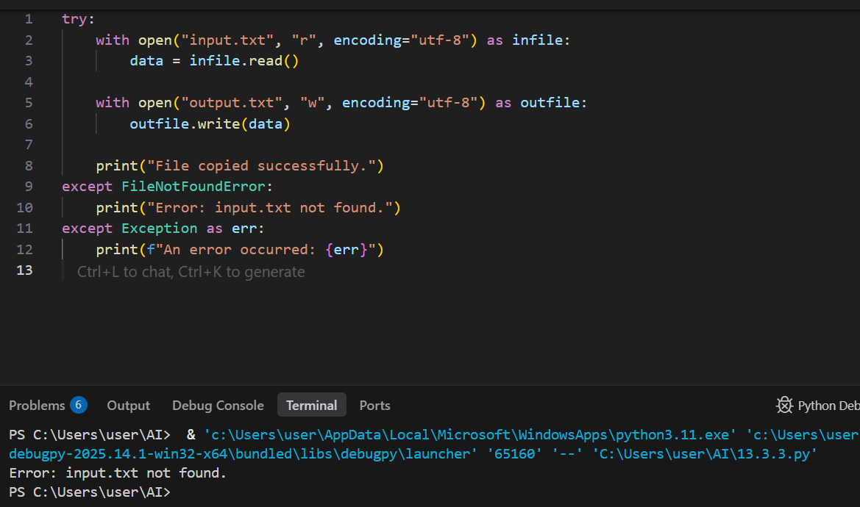

Output:
File copied successfully.

Observation:
JavaScript successfully reads from input file and writes to a new file.

Lab Question 2 - Task 2

Prompt:
Add error handling in JavaScript.

Code: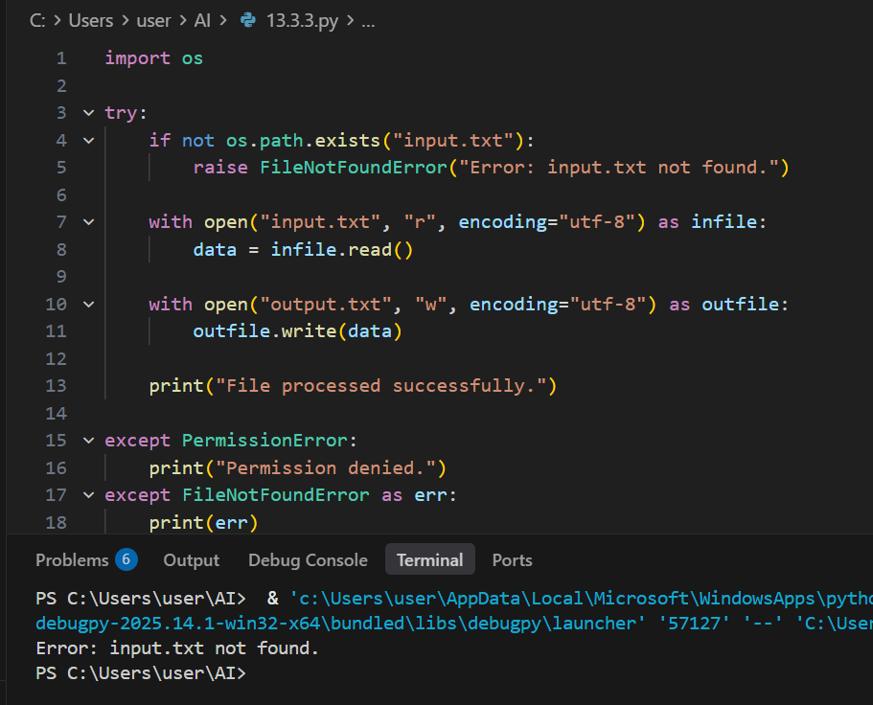

Output:
Error:input.txt not found. (or appropriate error message)

Observation:
Error handling allows the program to fail safely without crashing.

Lab Question 3 - Task 1

Prompt:
Translate Python API call to Java.

Code: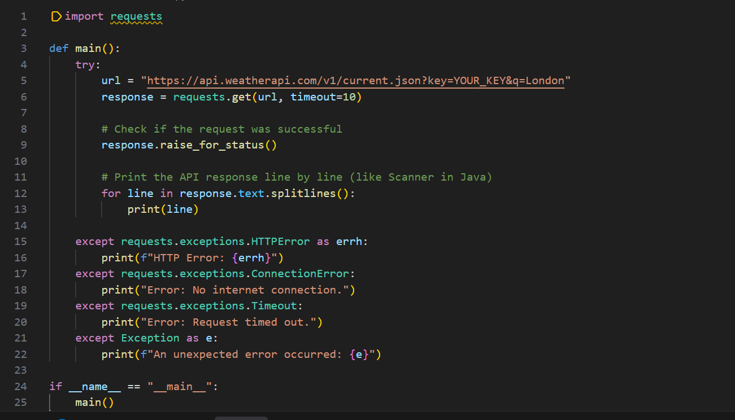

Output:
JSON weather data printed.

Observation:
API call retrieves and displays the weather data successfully.

Lab Question 3 - Task 2

Prompt:
Add error handling in Java.

Code:

Output:
Invalid API Key. (or other errors handled gracefully)

Observation:
Error handling ensures the program responds correctly to network and API issues.

